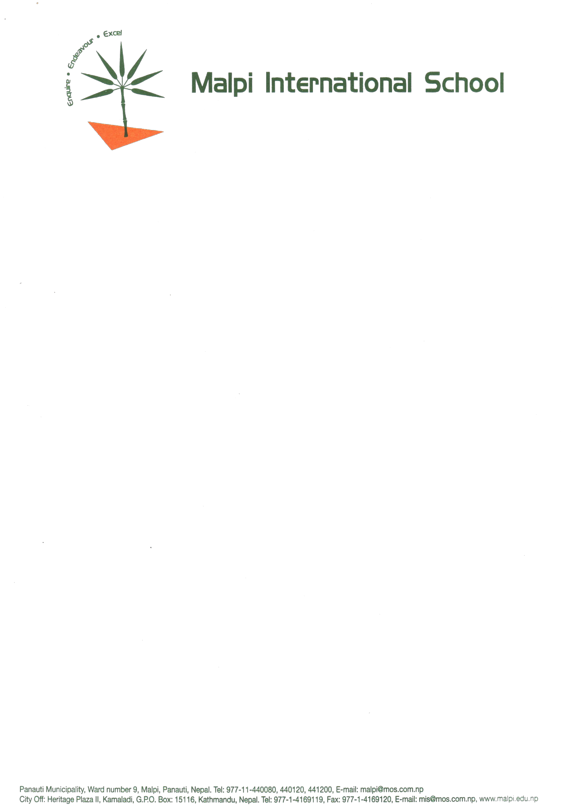

Admission Procedure

Enquiry and Visit:
Interested parents are encouraged to contact us and schedule a visit to learn more about Malpi International School and its environment. Appointments can be made by calling us at 011-440080, 440120, or 440121, or by emailing mi.school99@gmail.com with your details. Our school is located 33 km from the capital city of Kathmandu, nestled amidst the lush green hills of Panauti. Additionally, parents can visit our city office at Heritage Plaza II, Kamaladi, Kathmandu.

Admission Form:
Parents/guardians are required to complete an admission form, which can be filled out online or obtained in hard copy from the school or our city office at Heritage Plaza II, Kamaladi, Kathmandu. Along with the admission form, the following documents must be submitted:

  - Two updated passport-size photos of the student
  - Two updated passport-size photos of both parents
  - Birth certificate of the student issued by the ward office
  - Latest academic report of the student
  - Transfer/character certificate from the previous school
  - Medical/immunization records, if any

Admission Processing:
  - All admission applications will undergo a screening process.
  - (Residential Programme): For admission from Grades IV-IX, a written assessment of the child will be conducted, followed by an interaction session with the school principal.
  - (Day-Boarder’s Programme): Classes I to III on basis of previous grade sheet and interview classes IV to VI entrance test based on Maths, English and Nepali (Parents are requested to make an appointment in advance).
  - Parents will receive official notification regarding the admission status of their child after the interaction session via email or telephone.
  - Upon selection, parents will be provided with details on completing the admission formalities.
  - For further information or to schedule a visit, please contact us at the provided phone numbers or email address. We look forward to welcoming you to Malpi International School.

